**DMIT204 Project Mock-up – Adam Cass**

**Suggested Orders Webpage**

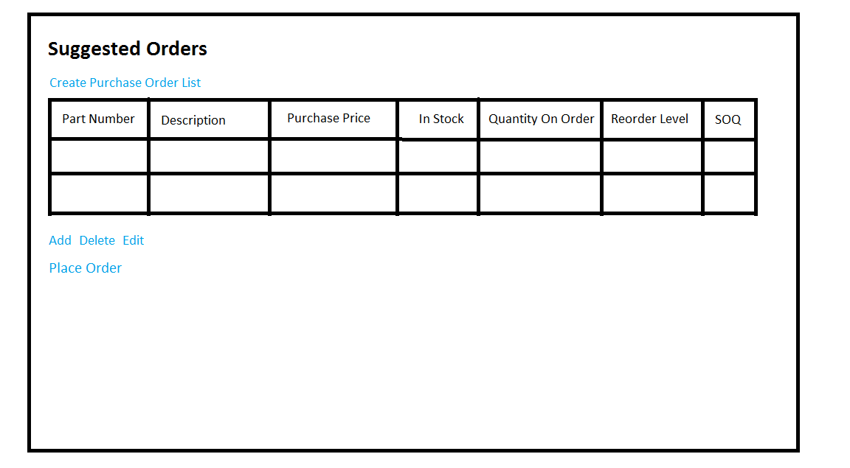

**Outstanding Orders Webpage**

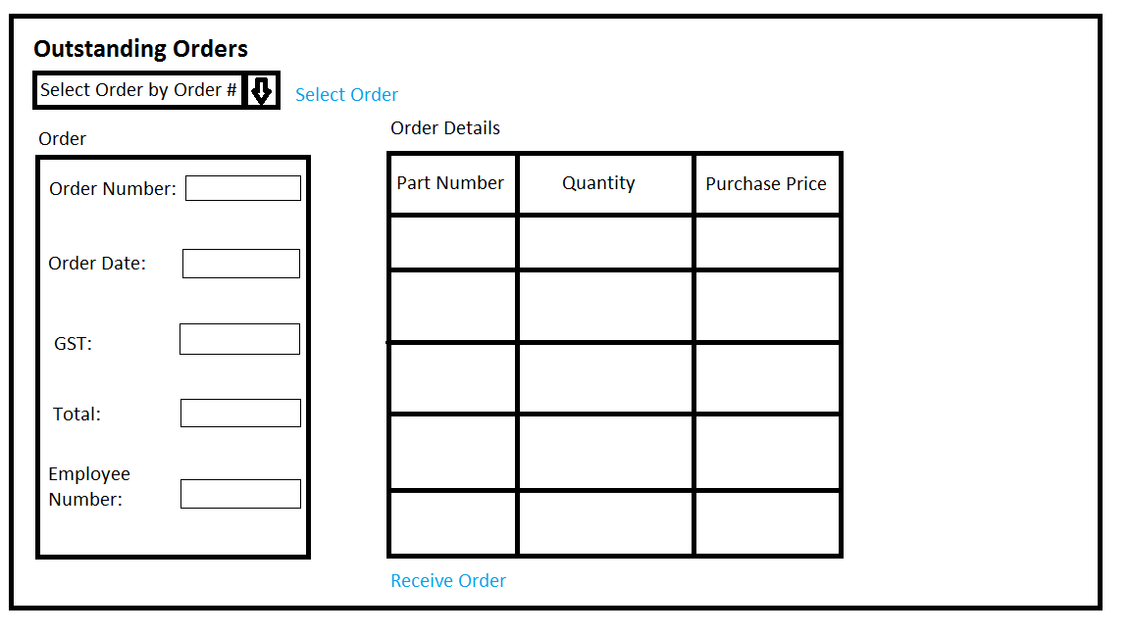

**Use Cases**

---------------------------------- Creating an Order List ---------------------------------------

**CreateSuggestedPurchaseOrderList ( ) --**

CreateSuggestedPurchaseOrderList receives three parameters representing Quantity (Integer), InStock (Integer), and ReorderLevel (Integer). The system uses the following equation and returns an complete Item record depending on the result, true or false: ReorderLevel – (InStock + UnitsOnOrder) > 0. If the result is true, the system returns the complete Item record and adds it to the order list.

**DisplaySuggestedOrderList ( )**

DisplaySuggestedOrderList receives a list of Parts (List). The system uses the Part information to calculate the suggested order quantity (SOQ) using the following equation: SOQ = ReorderLevel – (InStock + UnitsOnOrder). The system then returns multiple records of Part with the SOQ field filled in.

**UpdateSuggestedOrderList ( )**

UpdateSuggestedOrderList receives an updated instance of a Part (Object). The system updates the instance of Part with the new information input by the user.

**AddItemtoSuggestedOrderList ( )**

AddItemtoSuggestedOrderList receives one parameter representing the PartNumber (Integer). The system then allows the user to input an order quantity and adds the item to the suggested order list.

* **LookUpPart ( )** Should be able to look up DURING the add item process

LookUpPart receives one parameter representing the PartNumber (integer). The system returns the complete Item record.

**DeleteItemSuggestedOrderList ( )**

DeleteItemsuggestedOrderList receives a list of Part (List). The system removes a selected list item from Part with user input.

---------------------------------- Outstanding Orders -----------------------------------------------

**DisplayOutstandingOrders ( )** Include those with no receive date

DisplayOutstandingOrders receives one parameter representing the OrderNumber (Integer). The system then returns the complete record if the Receive Date (DateTime) field is null or empty.

**DisplayOrderandOrderDetails ( )**

DisplayOrderandOrderDetails receives one parameter representing OrderNumber (Integer). The system returns the full Order and OrderDetail record for the selected Order.

**CommitOrdertoStock ( )**

CommitOrdertoStock receives one parameter representing a list of Orders (List). The system updates the record of the Order with the input information (Receive Date - DateTime) and adds the ordered stock (Quantity – Integer) to the quantity on hand of the Part record (InStock - Integer).